
2025 Chili Challenge Food Safety Guidelines
Windsor Health Department: 860-285-1823

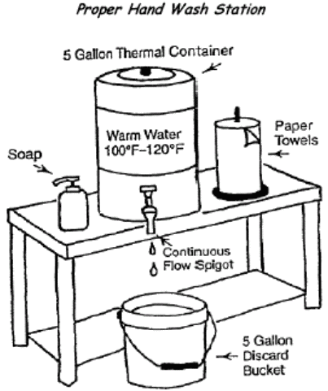
Please read and understand the following Windsor Health Department requirements.
- Each team is required to set up a temporary hand wash station equipped with a continuous flow spigot (see diagram). This must be in place and functioning prior to all food preparation. We will not allow you to begin without a hand wash station.
- Gloves are required for all personnel preparing or serving chili. Gloves must be powder free and latex free.
- Each team’s area is considered a separate temporary kitchen and must be maintained clean, organized and sanitary.
- Any chili or chili ingredient not cooked on site must be prepared in a food establishment holding a valid food permit.
- Unless you hold a valid food permit from the Windsor Health Department, permission must be granted to cook any chili or chili ingredient off site. Permission to cool in a licensed kitchen will only be allowed to participants with a manager’s food safe certificate from an approved testing agency.
- Vegetables may be washed and pre-portioned prior to the event, meats and other potentially hazardous foods must be prepared on site. Pre-washed vegetables are recommended. No vegetables can be pre-cut at home. All vegetables must be cut on site during the event.
- All meat products must be USDA approved and purchased from a commercial source, no home grown venison, chicken or pork, etc.
- Cold ingredients that require refrigeration must be transported in a cooler with ice or ice packs and maintained at 41 degrees F or below.

- All teams must have an NSF approved probe thermometer or digital thermometer that has a range of 0-220 degrees F. Thermometers must be cleaned and sanitized before and after each use. Sterile alcohol wipes are required.
- Chili must be cooked to a temperature of at least 165 degrees F for 15 seconds and held at 135 degrees F or above for the remainder of service. Make sure to have a long handled spoon for stirring.
- All food, utensils and single service items (utensils, spoons etc.) must be stored up off the ground and protected (covered). All utensils, spoons, etc… must be NSF approved. Boat paddles/oars are not permitted for use.
- Cutting boards must be hard maple or NSF approved plastic, free from deep gouges or cracks.
- Cutting boards, utensils, pots and pans must be washed, rinsed and sanitized prior to use.
- All food products must be purchased from a commercial source, save receipts.
- No homemade or home canned food is allowed.
- All food ingredients must be transported to the green in clean and sanitary covered food grade containers or food grade plastic bags at required temperatures (meats held below 41 degrees on ice).
- If you are a food establishment that is pre-cooking chili off site, cooked items must be hot held and transported to the town green in a gasketed, insulated food containers at a minimum of 135 degrees F.
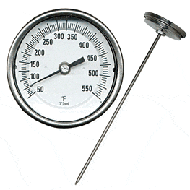
- Ice must come from a commercial source or a food establishment holding a valid food permit.
- Effective hair restraints (hat, hair net, beard guard, etc...) shall be worn by those engaged in food preparation or service. No sleeveless tops allowed. Aprons/clothing must be clean/soil free.
- No smoking of cigars, e-cigarettes, chewing tobacco etc… is allowed under the tents.
- Anyone who has experienced G.I. illness in the past several days leading up to the event (vomiting, diarrhea, or fever) is strictly prohibited from participating in food preparation or service. Open wounds or sores shall be properly covered.
- A milk crate is required to secure the propane tank. Cooking and heating areas must be protected from customers/patrons.
- Nothing can be stored on the ground. An extra table, pallet or cooler on wheels must be used to elevate supplies up off the ground.
- Chili is the only food to be served to the public by participants. Toppings such as cheese, creams or diced tomatoes shall be held at < 41 degrees F prior to serving.
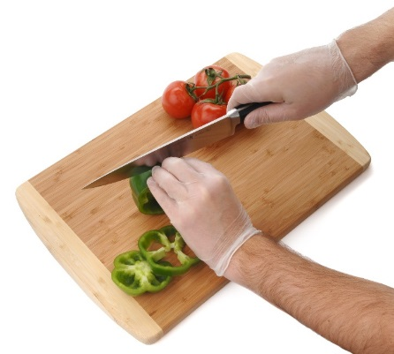
- Cooks are not to taste the chili with a cooking utensil, must use a disposable spoon. Spoon must be used only one time and then discarded.
A representative from each participating group must sign and date this form indicating that they have been made aware and fully understand the food safety guidelines for the 2025 Chili Challenge. The Windsor Health Department may be contacted at any time with questions related to food safety or food preparations at this event at 860-285-1823.
Organization/Group: ________________________________________________
Person in Charge: ___________________________________________________
Best Contact Number: _______________________________________________
Signature: _____________________________________Date: _______________

